FUNCTION AND PERFORMANCE TESTING
MODEL PERFORMANCE TEST

Date | FEB 2026
Team ID | LTVIP2026TMIDS37677
Project Name | ToyCraft tales: tableau's vision into toy manufacturer data
Maximum Marks

Model performance Testing:

S.NO | Parameter | Screenshot/values
1. | Data Rendered | Shown below
2. | Data Preprocessing | Shown below
3. | Utilization of Filters | Shown below
4. | Calculation fields Used | Shown below
5. | Dashboard design | No of Visualizations / Graphs
6. | Story Design | No of Visualizations / Graphs

Data Rendered
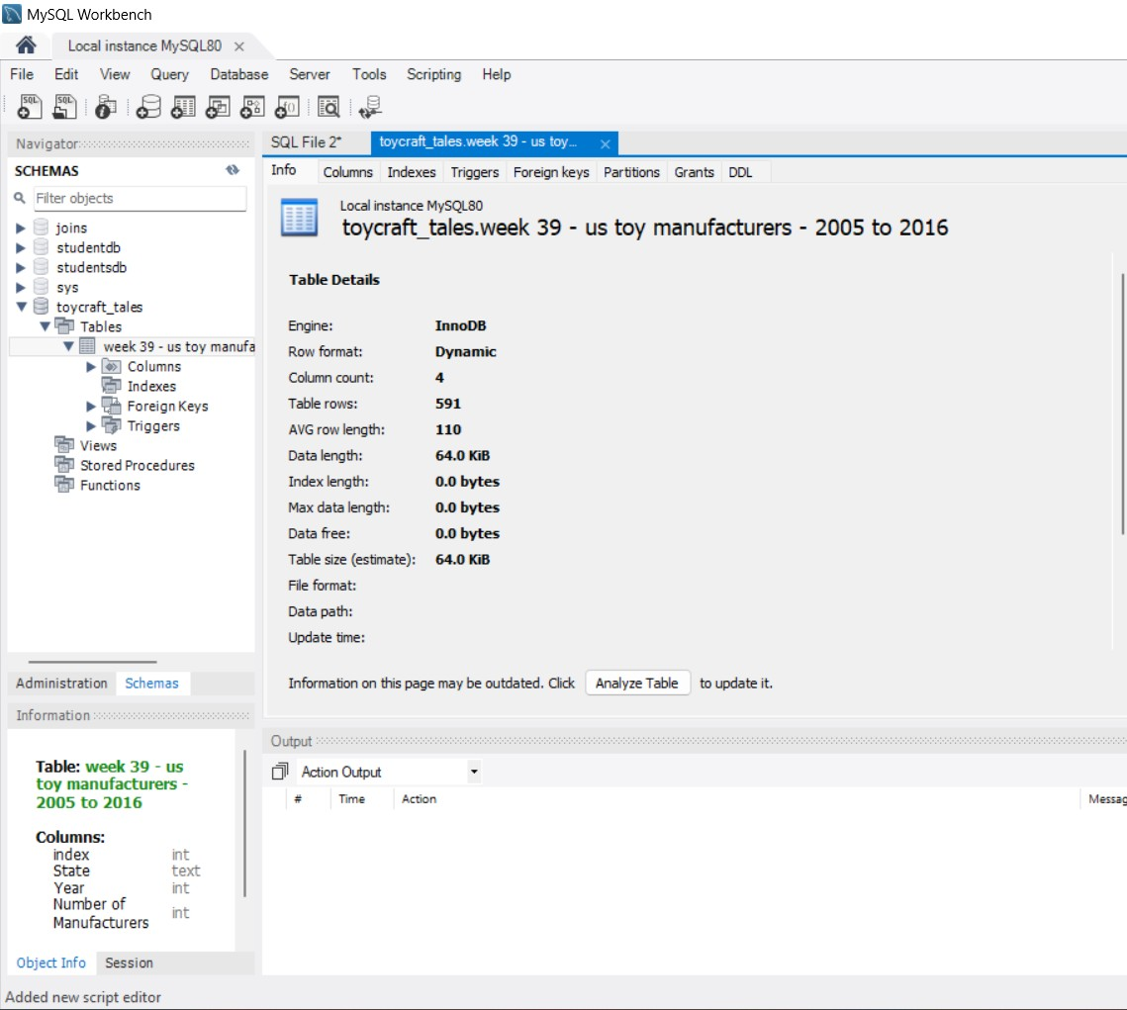

Utilization of filters
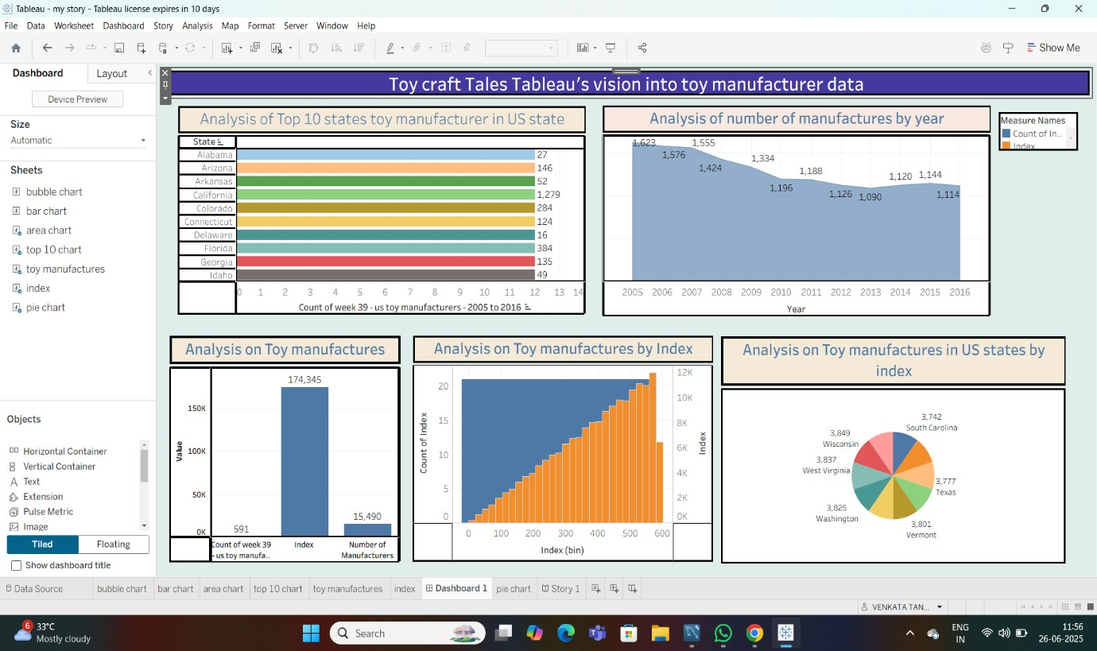

Calculation fields Used

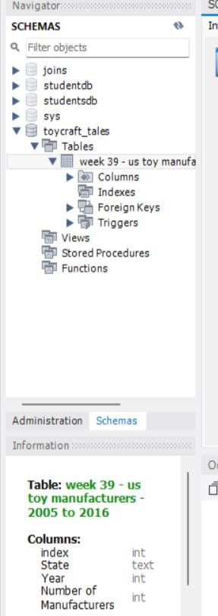

Dashboard design
- Analysis of the number of Manufacturers by Year
- Analysis of Toy Manufacturer by Index
- Analysis of toy Manufacturers in US state By Index
- Analysis of Toy Manufacturers
- Top 10 states toy manufacturer in US state

Story design
